CURRICULUM VITAE

**Personal Information**

* 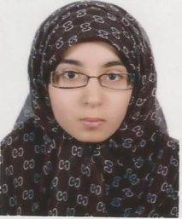Name: Ruqayah Saeed Salman Mushaimea
* Nationality: Bahraini
* Date of Birth: 1 October 1994
* Address: House No: 1539, Road 1434, Block 514 Jid AL-Haj
* Telephone No: 38099582
* Marital Status: Married
* CPR Number: 941000141
* Email: socio.uob@gmail.com

**Qualifications**

* B.A. in Sociology ( Social Theory and its Application) - Psychology

University of Bahrain 2019.

* Jidhafs Secondary Girls School ( Commercial Sciences) 2011/2012.
* Certificate of Achievement of Business Ethics Program 2011 .

Experiences

* Conducting and analyzing questionnaires for scientific research.
* Apply Psychological tests to individuals.
* Work of hair accessories and marketing 8 years.
* I participated in many marketing exhibitions.

Languages

* Arabic (speaking, reading and writing).
* English (speaking, reading and writing).

Skills & Strength

* Good Knowledge in Computer.
* Good communication with Skills.
* Able to work with team and hard working.
* Microsoft Office ( Word, Power point, Excel).
* Discipline in work and respect for appointments.
* Ability to withstand work pressure, Flexibility and acclimatization.
* Reading novels, Psychological books, educational and sociological books.

Personal

* Excellent health.
* Self-initiative.
* Time Management.
* Innovative and Creative.
* Maintain working team spirit.
* Valid clear Bahraini Driving License.
* Deal With Customer.
* Able to work in any position.